A Will for Wildlife

Bequests are the most common way to leave a legacy for nature. We are pleased that you are considering pledging a special donation for future wildlife protection work of the Sandy Pines Wildlife Centre.

You may wish to specify whether your gift should be available for our immediate use where it is needed most. We recommend that you discuss your will with your own legal and financial advisors. They can ensure that the wording of your will is legally valid in Ontario, and most importantly that it meets your desire to help the Centre. Adding a bequest can be as simple as adding one line to an existing will. We have included some sample clauses that may be helpful when you and your lawyer discuss ways to include Sandy Pines Wildlife Centre in your will...

As a sum of money or a particular property such as stocks or bonds:
“I hereby instruct my Trustee to pay out of my Estate to Sandy Pines Wildlife Centre (located at 8749 County Rd 2, Napanee, ON, K7R 3L1), the sum of $XXXX to be used in such a manner as it deems appropriate.” or “I hereby instruct my Trustee to transfer to Sandy Pines Wildlife Centre all my shares of ABC Company to be managed by said charity in a manner consistent with the mission and objectives of the said charity.”

As a percentage of your estate:
“I direct that my Trustee shall pay to Sandy Pines Wildlife Centre (located at 8749 County Rd 2, Napanee, ON, K7R 3L1), X percent (X%) of the value of my Estate, which sum I further direct may be used by Sandy Pines Wildlife Centre in any manner that it deems appropriate.”

As the residue of your estate, after your personal family commitments are met:
“I hereby instruct my Trustee to give to Sandy Pines Wildlife Centre (located at 8749 County Rd 2, Napanee, ON, K7R 3L1), XX percent (XX%) of the rest, residue and remainder of my estate, to be used for its general purposes.”

As a gift only in the event of death of heir(s) named in the will:
“If (primary beneficiary) does not survive me or shall die within ninety (90) days from the date of my death, then I instruct my Trustee to pay to Sandy Pines Wildlife Centre (located at 8749 County Rd 2, Napanee, ON, K7R 3L1), XX percent (XX%) of the rest, residue and remainder of my estate, to be used for its general purposes.”

As the residue after guaranteeing an income for the life of a loved one:
“If after the death of (name of beneficiary) to whom I have guaranteed an income for life as further described in clause (number) of this my will, there remains a residue in the fund established for the purpose of paying the said life income, I hereby instruct that the said residue be paid to Sandy Pines Wildlife Centre (located at 8749 County Rd 2, Napanee, ON, K7R 3L1) to be used for its general purposes.”

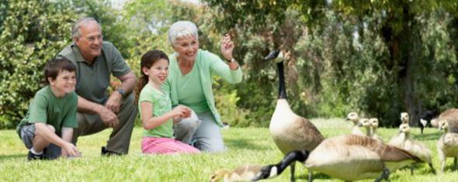
Bequests to Sandy Pines Wildlife Centre help us achieve many important wildlife rescue and rehabilitation successes as we progress into our third decade of operations. Our achievements are made possible because of the caring spirit and dedication of loyal donors as yourself. Thank you again for letting us know that you’re considering a bequest in your will towards this work. Your thoughtful gift will help us carry on into the future, protecting the unique species and diversity of Canada’s wildlife for years to come.
_________________________________________________________________________
Sandy Pines Wildlife Centre • 8749 County Rd 2 • Napanee, Ontario • K7R 3L1
www.sandypineswildlife.org info@sandypineswildlife.org (613) 354-0264

